# Dynamic staging/destaging in MSIX app attach

This article explains dynamics staging and destaging.

# What is staging?

MSIX app attach defines staging as an operation that:

* mounts an MSIX image from the MSIX file share
* parses the content of the MSIX image so relevant OS components can be notified that an MSIX packaged application is available
* dependencies are evaluated

MSIX app attach defines destaging as an operation that:

* removes references in the OS to the MSIX packaged application
* unmounts an MSIX image from the MSIX file share

Only MSIX packages with **State** set to active are staged.

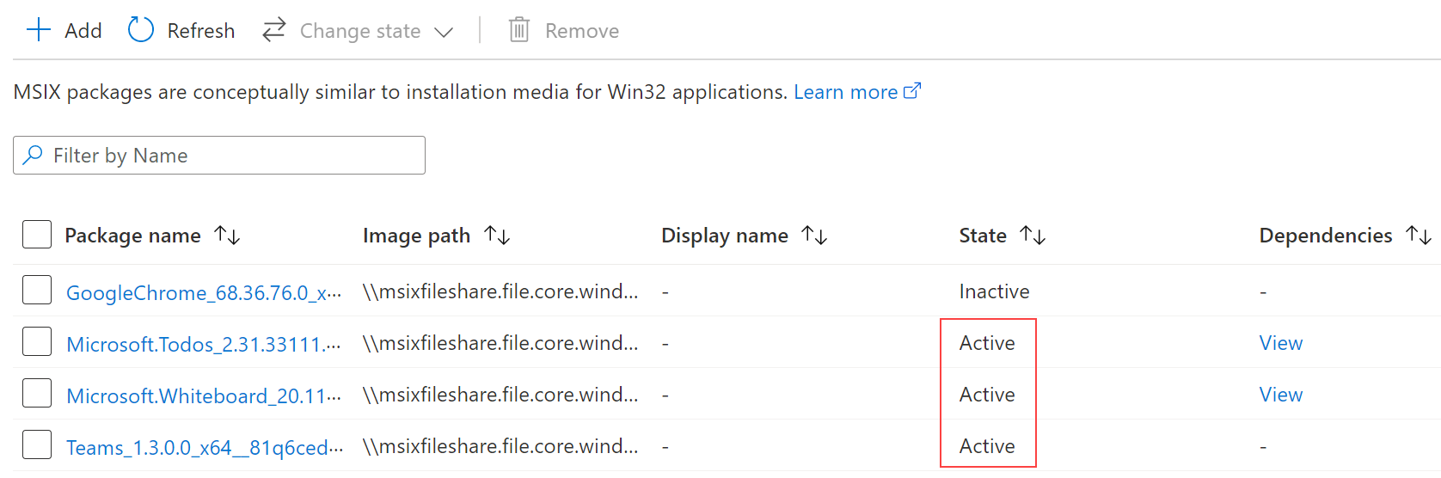

Staging happens per session host.

Staging an MSIX package does not grant users permissions to the MSIX application.

When staging fails, for any reason, the session host **Status** will become **Unavailable**. The status will remain until the issue blocking staging is resolved or the MSIX package is removed from the host pool.

Staged CIM packages do not appear in the Disk Management tool, only VHD(x) do. Both VHD(x) and CIM files show up when running **mountvol**.

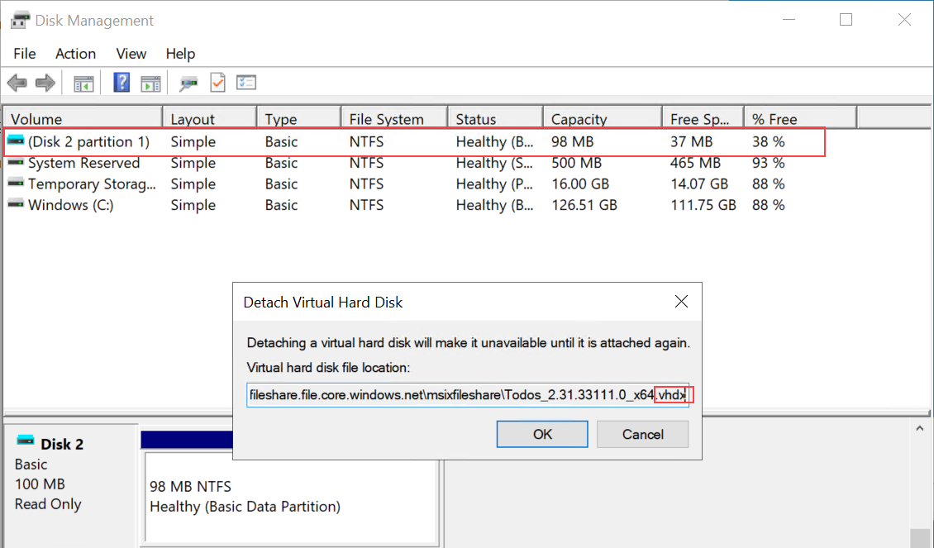

# What is destaging?

Destaging, does the opposite of staging by removing any reference in OS components and unmount the MSIX image.

Destaging cannot happen while the user has anapplication registered and running.

Restarting the **RDAgentBootloader** servicewill cause all MSIX images to be destaged and staged.

# Types of staging

There are two types of staging:

* Static
* Dynamic

Static staging happens when a session host VM starts up.

Dynamic staging happens when an IT pro adds a new MSIX package to the host pool and sets that package to active. When the package is added by default it takes up to 5 minutes before the MSIX image that contains the MSIX package is staged.

Session host VMs in a host pool are not synchronized to check at the same time for new packages. For example, session host VM#1 checks every 5 min starting 12:01, 12:06, etc. While session host VM#2 checks every 5 min starting 12:02,12:07, etc.

**Note:** If any users connect prior to staging of the MSIX image they will not see the application.